Biology, Castle View High School
Jason R Mayberry, PhD
Study Guide: Introduction to Organic Molecules
Vocabulary
- Proteins
- Nucleic Acids
- Carbohydrates
- Lipids
- Carbon Skeleton
- Functional Groups
- Polymer
- Monomer
- Condensation
- Hydrolysis
Short Answer
- Briefly Describe the roles each of the 4 organic Molecules plays in a cells structure and function
  - Lipids
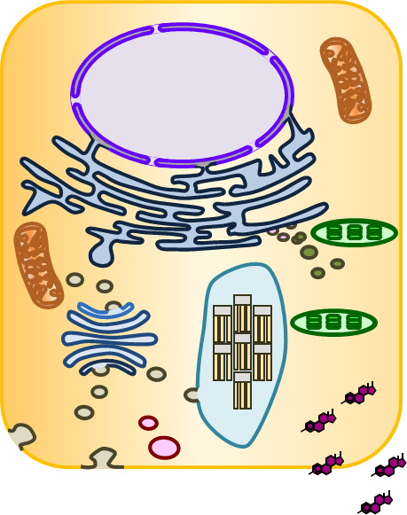
  - Nucleic Acids
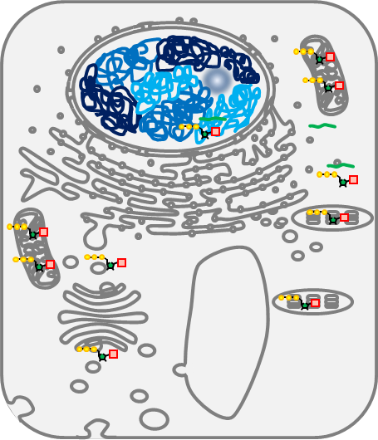
  - Proteins
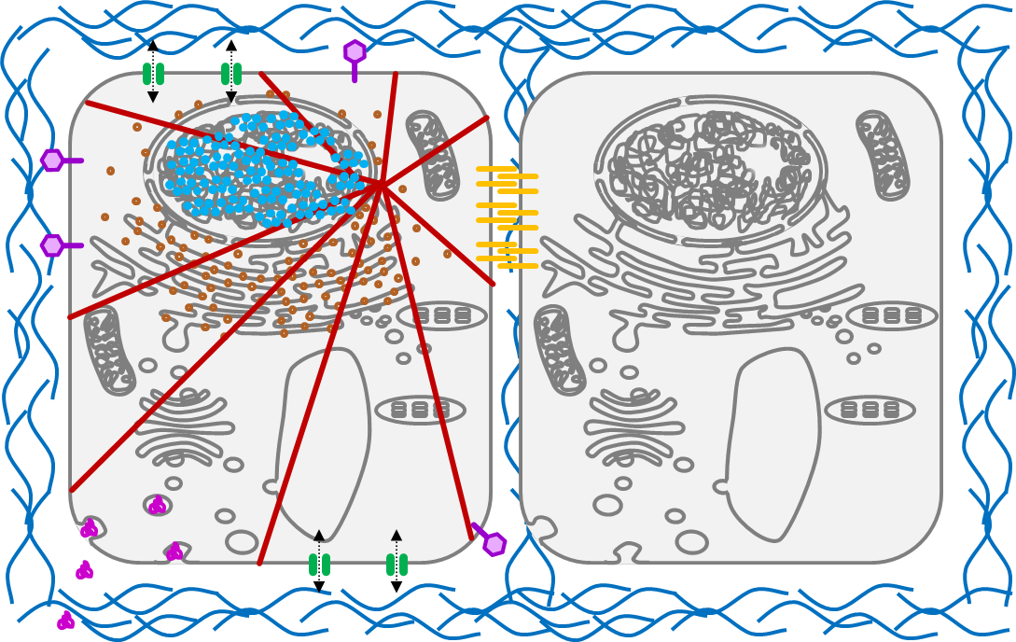
  - Carbohydrates
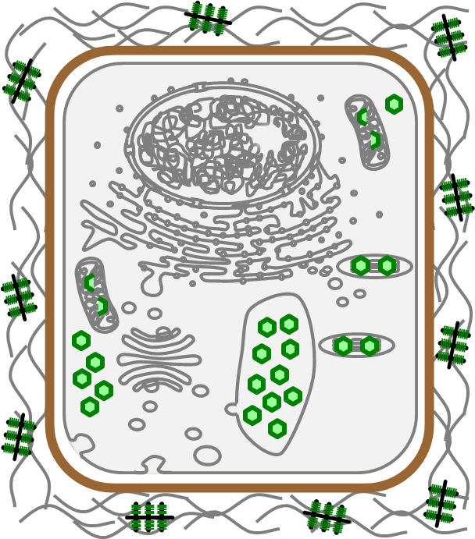
- What is the role of the Carbon Skeleton in Forming Organic Molecules
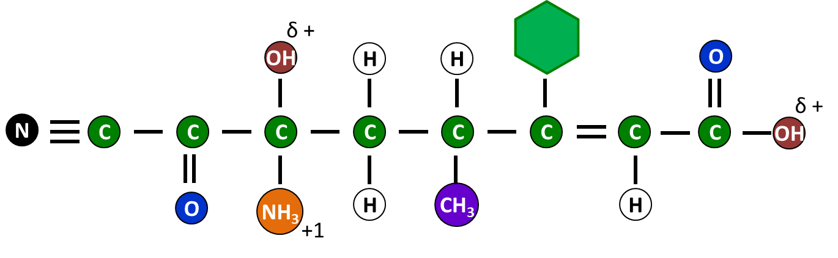

- What is the role of Functional Groups in Organic Molecules

- When using Line Drawings in Organic Molecules, what does each corner represent?

- What is the relationship between a Monomer and a Polymer?


- Describe what happens during a Condensation Reaction.
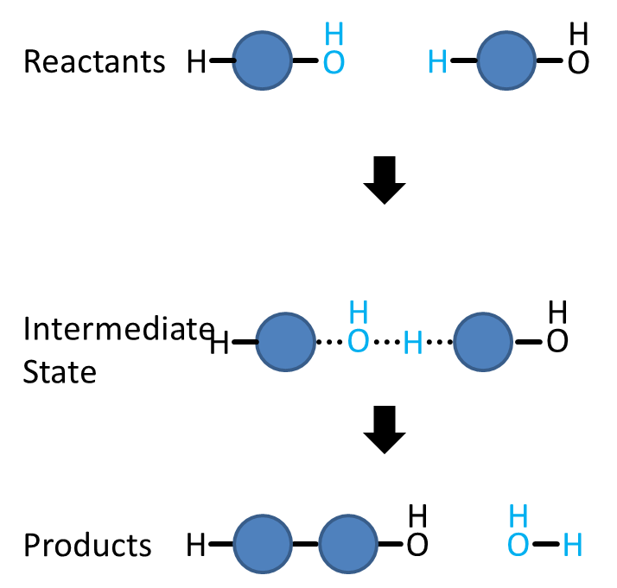

- Describe what happens during a Hydrolysis Reaction.

